JOBS | Monday | Tuesday | Wednesday | Thursday | Friday | Saturday | Sunday
 | Joe | Joe | Joe | Joe | Joe | Joe | REWARD
 | Mary | Mary | Mary | Mary | Mary | Mary | Mary
 | Joe | Joe | Joe | Joe | Joe | Joe | Joe
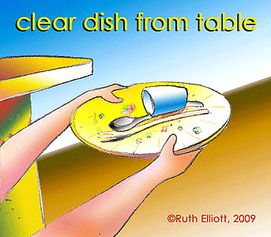 | Mary | Mary | Mary | Mary | Mary | Mary | Mary
 | Joe | Joe | Joe | Joe | Joe | Joe | Joe
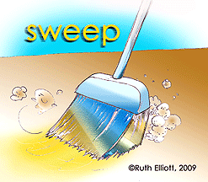 | Mary | Mary | Mary | Mary | Mary | Mary | Mary
 | Joe | Joe | Joe | Joe | Joe | Joe | Joe
 | Mary | Mary | Mary | Mary | Mary | Mary | Mary
www.gomommygo.com All images © Ruth Elliott, 2002-2010
This is a sample of how you might allocate jobs for more than one child, using one chart. Find other images on the link available here.

