Positive behavior | Monday | Tuesday | Wednesday | Thursday | Friday | Saturday | Sunday
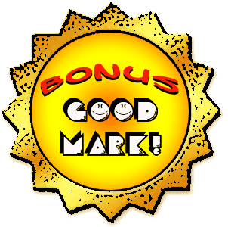
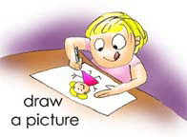
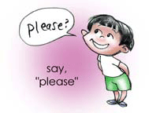
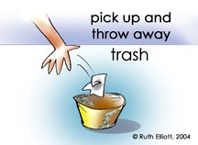
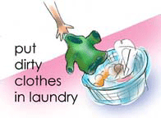
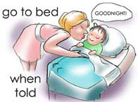
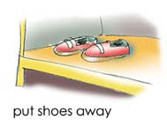
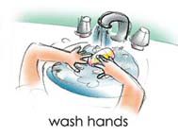
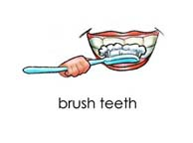
All images © Ruth Elliott, 2002-2012
Get your free CUSTOMIZABLE Illustrated Behavior Charts at www.GoMommyGO.com
GoMommyGO is a Registered Trademark of EDU DESIGNS, a CA Non Profit 501(c)(3) Corporation
Fed. Tax ID # 261576531 PO Box 2664, Rancho Cucamonga, CA 91729

