Family  Service | Choose DAILY or | WEEKLY
Family  Service |  | Mon | Tues | Weds | Thurs | Fri | Sat
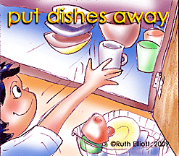 | Empty dishwasher | Jon | Lisa | Jon | Lisa | Jon | Lisa
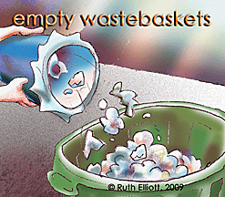 | #__ days a week (especially Day Before Trash pickup) | Lisa |  |  |  | Lisa
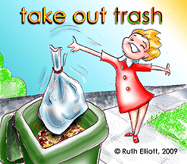 | 1-Take out Trash cans night before  2- bring in empty trash cans after Pick up |  | Jon | Jon
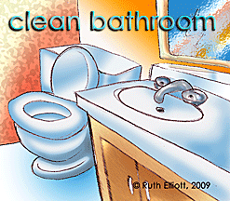 | Clean bathroom each week |  |  |  |  |  | Lisa
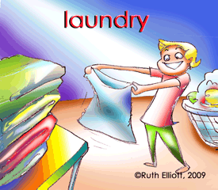 | 1 Load per week |  | Lisa |  | Jon
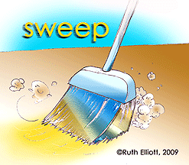 | Sweep kitchen 1x each week |  |  | Lisa
 | Mop kitchen 1x each week |  |  |  |  | Jon
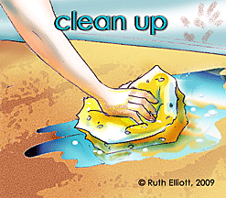 | Outside kitchen cabinets 1x each week |  |  |  | Lisa
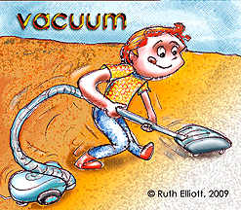 | Vacuum 1x each week (+ couches if needed) |  |  |  |  |  | Jon
© Ruth Elliott, 2003-2012 Get Free Behavior Charts from GoMommyGO® www.GoMommyGO.com

